EXPERIMENT NO: 1
OBJECTIVE: VERIFICATION OF KIRCHHOFF’S LAWS
- Kirchhoff’s current law(KCL)
- Kirchhoff’s voltage law(KVL)
APPARTAUS REQUIRED:
Sl no. | Apparatus | Type | Range /specification | Qty.
1 | Experimental board | Kit or  Bread Board |  | 1
2 | Power supply | DC | 9V & 5V | 1
3 | VOLTMETER | Moving-Iron | 0-15V | 1
4 | AMMETER | Moving-Iron | 0-100mA | 1
5 | CONNECTING WIRES |  |  | As required
THEORY:
I) Kirchhoff’s current law (KCL): It states that the total algebraic sum of current meeting at the junction is zero. This law is based on the principle of conservation of charges.

KCL at junction “O”
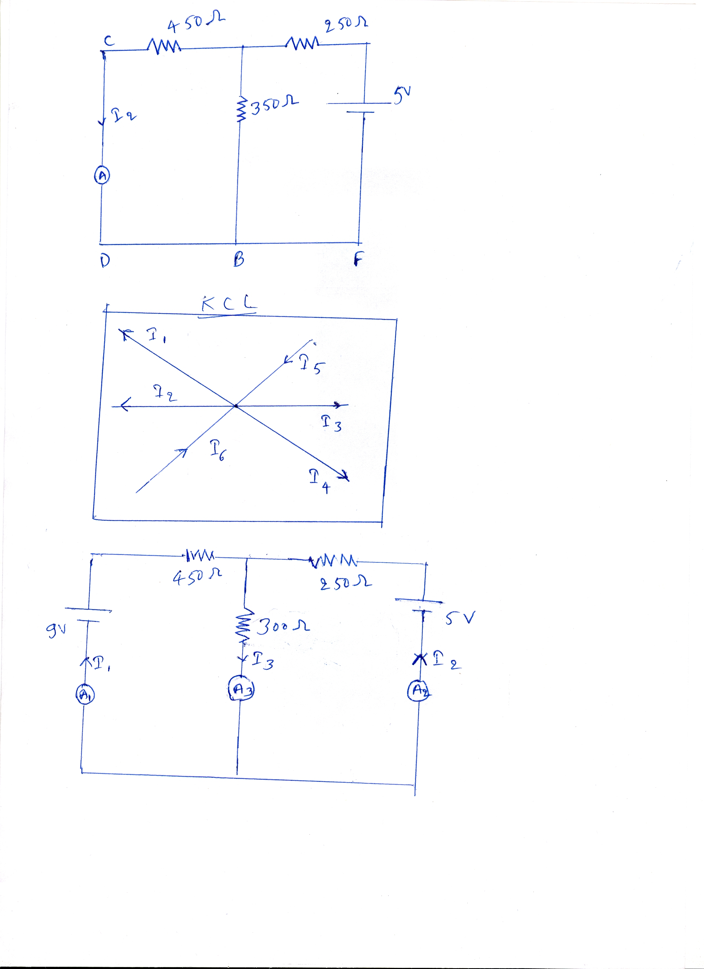
I₁+ I₂+ I₃+ I₄ - I₅ - I₆ =0
Therefore, I₁+ I₂+ I₃+ I₄ = I₅+I₆
CIRCUIT DIAGRAM:
PROCEDURE:
- Connect the circuit. As shown in circuit diagram.
- Switch on the power supply.
- Note the reading of ammeter

OBSERVATION TABLE:
Sl no. | I₁ (A)  practically | I₂ (A)  practically | I₃ (A)  practically | I₃ (A)  calculated | I₃ = I₂+I₁

CALCULATION OF CURRENT “I₃”
I₃ = I₂+I₁
RESULT:
Add the reading of ammeter 1(A₁) & ammeter 2(A₂) and it will be equal to reading of ammeter 3(A₃)
I₃ = I₂+I₁
KCL is verified.
PRECAUTION:
- All connection should be tight.
- Before connecting the instruments check their zero reading.
- The terminal of the resistance should be properly connected.

ii) Kirchhoff’s voltage law (KVL):
It states that the algebraic sum of voltage through a closed loop is zero. This law is based on the principle of conservation of energy,
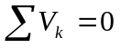
Where, 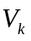 is the branch voltage of close path.
CIRCUIT DIAGRAM:
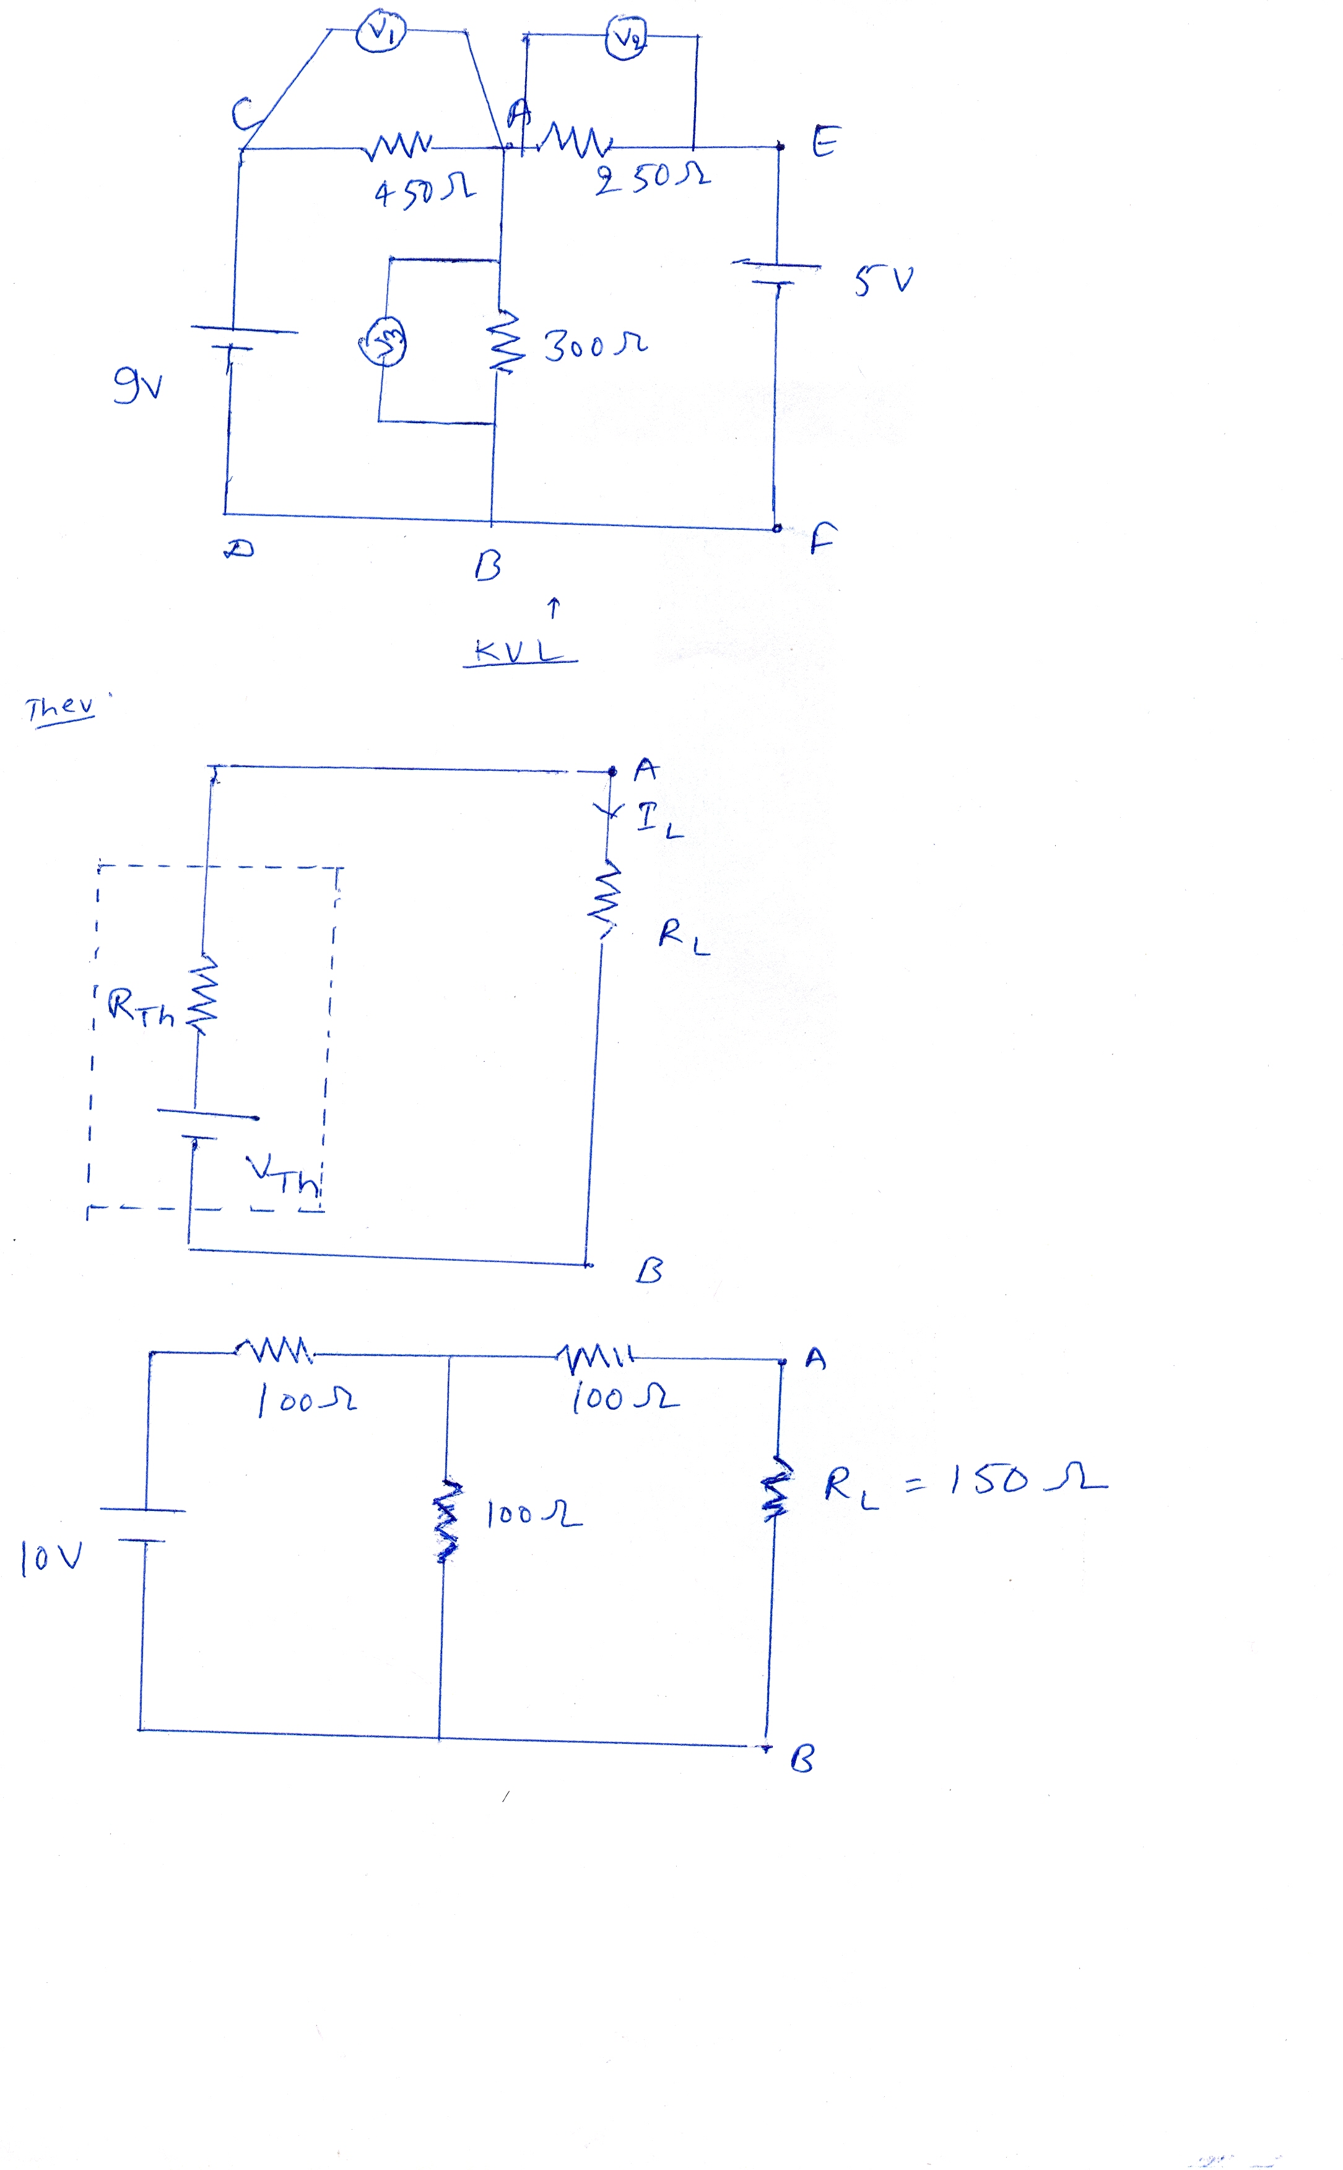
PROCEDURE:
- Connect the circuit. As shown in circuit diagram.
- Switch on the power supply
- Note the reading of voltmeter. V₁,V₂,V₃ (with polarity)

.

OBSERVATION TABLE:

Sr No | Supply voltage | V₁ | V₂ | V₃ | (Mesh 1) | (Mesh 2)
1 | 9V
2 | 5V
3 | 9V & 5V

RESULT:
The algebraic sum of voltages in each close path (Mesh 1 & Mesh 2) is zero. Hence, KVL is verified.
PRECAUTIONS:
- All connection should be tight.
- Before connecting the instruments check their zero reading.
- The terminal of the resistance should be properly connected

